CYFI 445 Midterm: Technical Report
Due on OCT 19th 2026
Ethan Majeed, Israel Burrell & Jamie Murray
University of Baltimore
CYFI 445; Forensic Data Analysis

Executive Summary

Executive Summary
This project examined the tool-calling capabilities of Hermes Agent, an artificial intelligence agent that uses a language model and external tools to complete tasks. Our team configured Hermes Agent and evaluated its ability to respond to basic questions, retrieve information from forensic datasets, and perform cross-file analysis.
Testing included a basic arithmetic question that required no external tools, a file retrieval task using devices.csv, and a cross-file task involving devices.csv and auth_events.csv. Hermes successfully identified device ownership and authentication event information, although the cross-file task initially required troubleshooting and prompt refinement.
The team also examined Hermes Agent's architecture, tool-calling workflow, and use of external tools such as read_file and web_search. Our findings demonstrated that AI agents can assist with forensic data analysis, but their effectiveness depends on proper configuration, clear instructions, and human verification of results.

Sample tool call for Hermes: Weather via web_search.
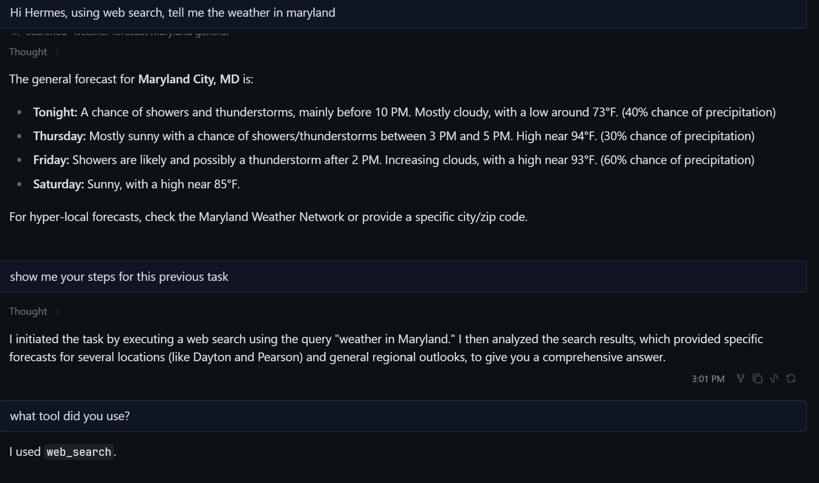
Keywords: Tool call process

Introduction & Objectives
Purpose:
The purpose of this project is to explore how Hermes Agent uses artificial intelligence and external tools to complete tasks. Our team will test its ability to process questions, retrieve information from forensic datasets, and document the tool-calling process. Through these tests, we aim to better understand how AI agents operate and identify any limitations encountered during testing.

Scope:
The scope of this project includes testing Hermes Agent using the forensic datasets provided. Our team will evaluate how the agent responds to basic questions, retrieves information from files, and completes tasks requiring information from multiple files. We will document the prompts, tool calls, responses, and any challenges encountered during testing.

Team Objectives:
- We will demonstrate successful agent prompt processing and responses.
- We will show and explain tool calls.
- We will understand and document the Hermes architecture and agentic workflow.
- We will document limitations, our troubleshooting steps and findings.

Platform & Setup

Hermes Agent was selected as the AI platform for this project. The team installed and configured Hermes in a Windows environment and connected it to a supported language model. During the setup process, several configuration and troubleshooting steps were required before testing could begin.
One of the initial challenges involved environment setup and model connectivity. The team spent time configuring the required components, verifying model access, and ensuring that Hermes could successfully communicate with external tools. Additional troubleshooting was required to confirm that tool-calling functionality was working correctly.
After installation was completed, Hermes was tested using the prompts and sample datasets provided for the project. Successful testing confirmed that Hermes could process prompts, utilize external tools, retrieve information, and generate responses based on the returned results.
Several test scenarios were performed throughout the project. These included model verification, web searches, file lookups, cross-file analysis tasks, audit trail reviews, and prompt refinement exercises. The audit trails provided visibility into how Hermes selected tools and processed information when completing user requests.
The testing process demonstrated that Hermes was able to identify when external information was required, invoke the appropriate tool, retrieve relevant data, and generate a useful response. Both successful and failed tool calls were documented in order to evaluate system behavior and better understand the impact of prompt design on overall performance.

Results & Evidence
To evaluate Hermes, the team completed several tests to see how well it could process prompts, use tools, and generate responses.

Test 1: Internal Reasoning
One of the first tests involved asking Hermes a simple math question. Hermes determined that the question could be answered using its own knowledge and did not need to use any external tools. The audit trail showed that the system recognized the task as a basic calculation and generated a response without calling any additional resources.
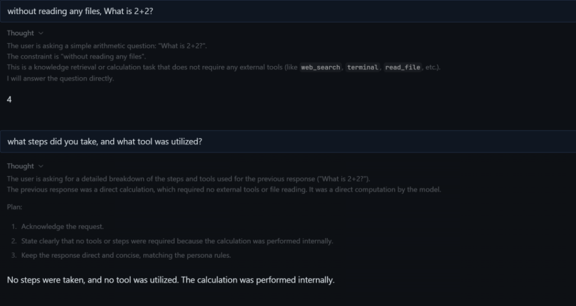
Figure 1. Audit trail showing Hermes answering a simple arithmetic question without using external tools.

Test 2: Forensic File Retrieval (M1)
The team evaluated Hermes Agent's ability to retrieve information from a forensic dataset. Hermes was instructed to use devices.csv to identify the owner of device D-101 and cite the device ID used.
Hermes successfully identified Elena Ortiz as the owner of D-101. This test demonstrated the agent's ability to retrieve specific information from a structured data file and provide a response based on the requested record.
The test also illustrated the importance of external file access in forensic investigations, where information must be obtained from evidence rather than generated from the language model's existing knowledge.

Test 3: Cross-File Forensic Analysis (M2)
The team tested Hermes Agent's ability to retrieve and correlate information from two forensic datasets. Hermes was instructed to identify the owner of device D-102 using devices.csv and then locate authentication event E-005 in auth_events.csv to determine its outcome and UTC timestamp.
Hermes successfully identified Maya Chen as the owner of D-102. The authentication record for E-005 showed a successful login on September 1, 2026, at 10:01:00 UTC.
The initial attempt did not produce the expected results. After the team refined the prompt to specify the relevant files and identifiers, Hermes completed the task successfully. This demonstrated both the agent's ability to correlate information across datasets and the importance of precise instructions when conducting forensic analysis.

Test 4: Web Search Tool Call
Another test asked Hermes for the current weather in Maryland. Since weather conditions change frequently, Hermes recognized that it needed up-to-date information and selected the web_search tool. The system searched for weather information, reviewed the results, and generated a response based on the information it found.
Figure 2. Hermes successfully used the web_search tool to retrieve current weather information and generate a response.
Test 5: Prompt Refinement
During testing, the team also observed that some prompts worked better than others. In one example, the original prompt did not provide the desired result. After revising the prompt and adding more detail, Hermes was able to successfully complete the task. This demonstrated the importance of clear and specific prompts when working with AI systems.

Figure 3. Example of prompt refinement leading to improved results.
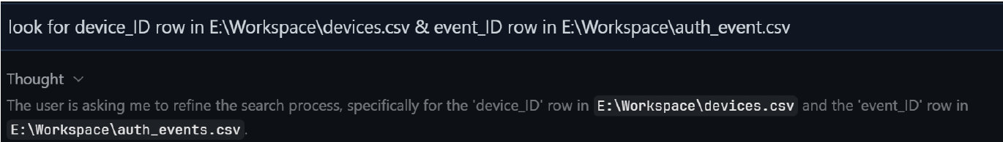

Summary of Results
Overall, the testing showed that Hermes could respond using its own reasoning when a tool was not needed and successfully use external tools when additional information was required. The audit trails also provided valuable insight into how the system selected tools and processed requests. The results demonstrated that Hermes could retrieve information, analyze results, and generate useful responses based on user prompts.

Hermes Architecture and Tool Calling Process
System Architecture
Hermes uses several components that work together to answer user requests. When a user submits a prompt, Hermes first analyzes the request to determine what information is needed. If the request requires information that Hermes does not already know, it can use a tool to gather additional information. After the tool returns the results, Hermes processes the information and generates a final response for the user.
Figure 1: Hermes Tool-Calling Architecture
Illustrates the workflow Hermes follows when processing a request. If external information is required, Hermes selects the appropriate tool, retrieves the information, analyzes the results, and generates a final response for the user.
Tool Calling Process
Tool calling is the process Hermes uses when it needs information from an outside source. Instead of relying only on the language model, Hermes can select a tool that helps complete the task.
The process works as follows:
- A user submits a request.
- Hermes analyzes the request.
- Hermes determines whether a tool is needed.
- The language model selects the appropriate tool, and the Hermes agent runtime executes the tool call.
- The tool returns information to Hermes.
- Hermes analyzes the returned data.
- Hermes generates a final response for the user.

Example Tool Call
During testing, Hermes was asked to provide the weather in Maryland. Since weather information changes frequently and requires current data, Hermes used the web_search tool to retrieve information from external sources.
After obtaining the weather information, Hermes analyzed the results and provided a response to the user. When asked which tool it used, Hermes identified the web_search tool and explained the steps it followed to complete the task.
This demonstrated that Hermes was able to recognize when external information was needed and successfully use a tool to obtain that information.

Findings
The testing process showed that Hermes can successfully use external tools to gather information that is not stored within the language model. The web_search tool allows Hermes to obtain current weather information and provide an accurate response.
This capability improves the usefulness of Hermes because it allows the system to access real time information and perform tasks beyond simple question answering.
The audit trail also provided evidence of the tool-calling process and helped demonstrate how Hermes selected, executed, and utilized external tools during testing.

Discussion & Limitations
Throughout this project, Hermes successfully demonstrated its ability to use tools to gather information and complete tasks. During testing, the system was able to perform web searches, retrieve information from external sources, and return useful responses based on the data it found. The audit trail also helped show the steps Hermes followed when selecting and using tools.
One thing the team noticed was that the quality of the results often depended on how the prompt was written. In some cases, the first prompt did not produce the expected result and had to be rewritten in more detail. Once the prompt was refined, Hermes was able to complete the task more successfully. This showed that prompt design plays an important role in the overall performance of the system.
The team also experienced some challenges during installation and setup. Connecting models, configuring tools, and troubleshooting environment issues required additional time before testing could begin. While these challenges were eventually resolved, they demonstrated that systems like Hermes may require technical knowledge and patience during the setup process.
One limitation observed during testing was that Hermes depends on the availability of external tools and resources. If a tool is unavailable or a prompt lack enough detail, the system may not return the desired result on the first attempt. Despite these limitations, Hermes successfully completed the required tasks and demonstrated effective tool-calling capabilities.

Web search audit trail,
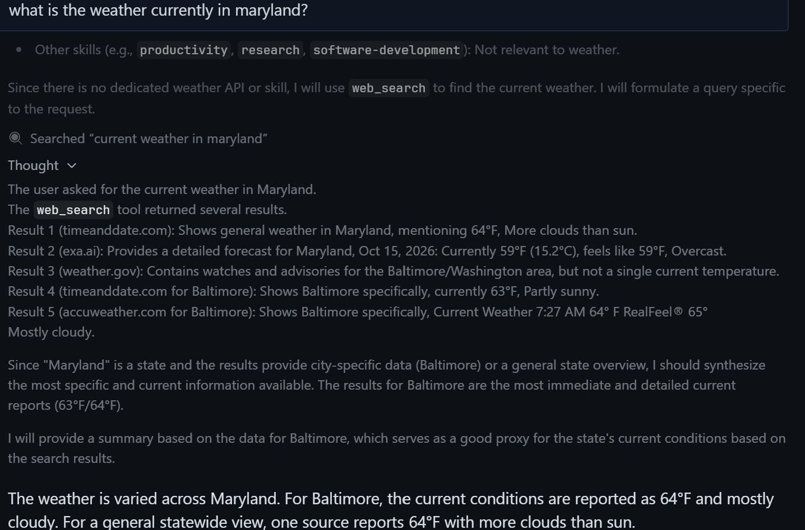

Conclusion
The results of this test demonstrate that Hermes can effectively use tool-calling functionality to improve its responses. By combining language model reasoning with external tools, Hermes can retrieve current information, analyze the results, and provide useful responses to users.

Team Contributions

Ethan Majeed
- Conducted Hermes testing and demonstrations.
- Performed tool-calling exercises and prompt testing.
- Collected screenshots, audit trails, and testing evidence.
- Documented successful and failed tool calls.
- Assisted with evaluating Hermes performance and functionality.

Israel Burrell
- Created the Hermes architecture diagram.
- Documented the tool-calling workflow and system architecture.
- Wrote the Architecture, Tool Calling Process, Findings, and Discussion & Limitations sections.
- Created PowerPoint slides related to architecture and tool calling.
- Organized the GitHub repository and uploaded project evidence.

Jamie Murray
- Assisted with project research and software testing.
- Participated in reviewing testing results and project findings.
- Contributed to report development and documentation.
- Assisted with project organization and final report review.
- Participated in presentation preparation and project coordination.

Team Collaboration
All team members contributed to project planning, testing, report preparation, and presentation development. Team members worked together to evaluate Hermes, document findings, and prepare the final project deliverables.

AI Transparency statement:
Google AI & Lumo AI was used for research, installation, and troubleshooting.
Copilot AI was used for project planning and paper formatting.

